One of the features of modern marketing and advertising is the exploitation of the artist’s celebrity status and reputation to promote a third party’s products or services. This takes two different forms: sponsorship and endorsement.

Sponsorship usually involves the sponsor doing or providing something (e.g. money, radio/TV exposure, companies own product or services) to an artist to assist a company or event and by that, gaining a commercial benefit by the association. Endorsement is an active promotion by the artist of the company’s products or services.

Part 14 includes some standard terms of an endorsement proposal and some additional marketing activities to be undertaken by the Artist.
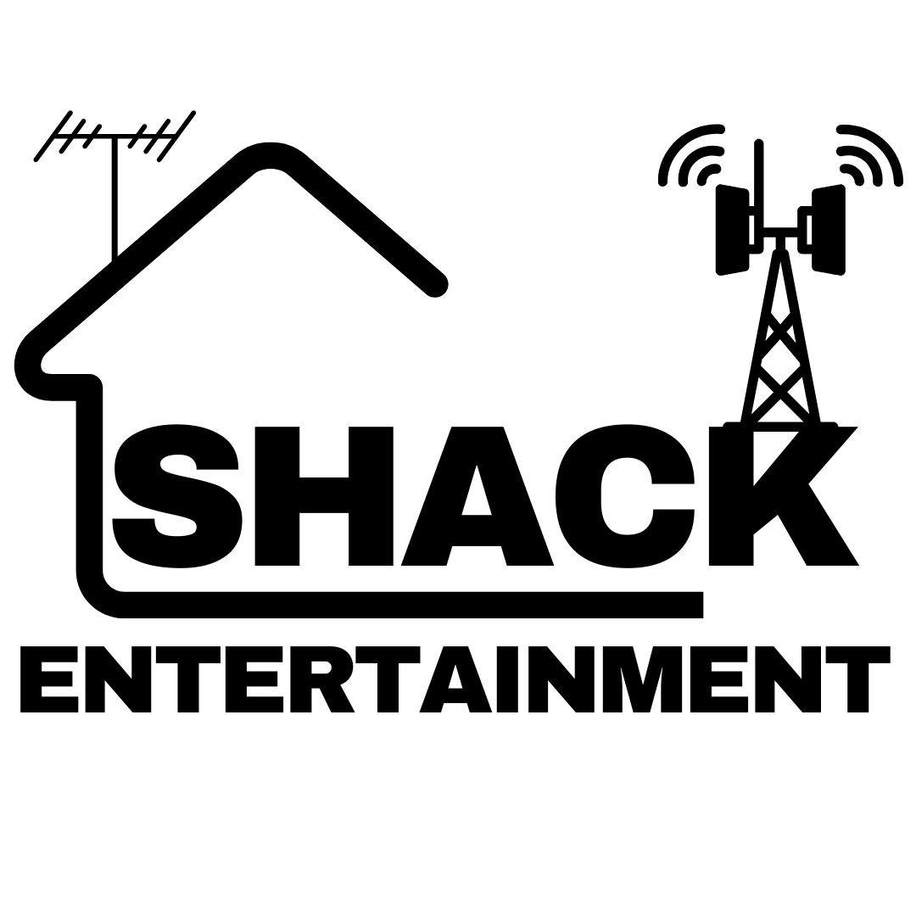

SPONSORSHIP AND ENDORSEMENT AGREEMENT

The following will serve as the agreement between [name of the sponsor] (hereinafter the "Sponsor") and Shack Entertainment (hereinafter the "Manager") for the services of Shack Entertainment (hereinafter referred to as the "Artist") at an event (or series of events) “The Live Exchange Shows” (hereinafter the “Event”) in connection with the Sponsor's products and services (all collectively hereinafter referred to as the "Products").

- Sponsor shall be the (Part) or (Exclusive) sponsor of the Event or Events tentatively scheduled for [Event date(s)].

- Without limiting the generality of the foregoing, no other party (e.g. a local radio/TV station or product manufacturer/service provider) may be listed or mentioned as a sponsor or presenter in association with Shack Entertainment of the specific Event.

- As full compensation for the rights and services granted herein, Sponsor shall pay the company the
sum of £ [ ].fee payable by Sponsor to the Company

- In connection with said Event, Sponsor shall receive [number of tickets] tickets at no cost for each performance. Such tickets shall be for favourable seats in the highest price range and locations. In addition, Sponsor shall have the right to purchase, at the ticket's face value price, up to ten percent (10%) of concert tickets at each venue, said tickets to be made available at the earliest date(s) possible.

- (a) An official logo and identification phraseology or catch phrase shall be developed for the Event by Shack Entertainment which shall be subject to the approval of the Sponsor and which shall refer to Sponsor (in first position) and Event/Artist (e.g. Sponsor presents Event/Artist). Such logo and/or identification phraseology, where applicable, shall be prominently included in all promotional and advertising references which relate to the Event and disseminated throughout any media (e.g. print, online,
- Youtube and point of sale) by promoter or company publicising the Event. Nothing herein contained shall constitute an obligation on Sponsor's part to advertise or promote the Event, it being understood by the parties hereto that the Sponsor may do so at its option or may refrain therefrom.

(b) Any uses of the official logo and/or identification phraseology or catch phrase, other than specifically provided for in this Agreement, shall be agreed by both Sponsor and Manager.

  - Sponsor's sponsorship of the Event shall be prominently featured and/or displayed in, including but not limited to, references on tickets, passes, handbills, inflatables (where applicable), indoor and outdoor venue signage (where applicable), venue marquee, stationary (if any), press releases, the stage and curtain (where applicable) and a sponsor reference on the front cover of any official programs. The form of such sponsorship references shall be subject to the mutual approval of the Sponsor and Manager.
  - Sponsor shall be responsible for providing banners with its name and/or logo of Sponsor's products and/or references to its sponsorship of the Event containing references to the Sponsor/Products which banners Manager shall cause to be prominently displayed in the venue(s), graphic layouts, vehicles signage and any other materials deemed necessary or desirable by both Sponsor and Manager.
  - A Sponsor's sponsorship reference(s) shall appear on the backside of all T-shirts and on all other clothing items sold (the manner and location of such sponsorship reference on such other clothing to be determined by Manager and approved by Sponsor), which are offered for sale to the public; provided, however, if Manager feels it advisable, up to twenty-five percent (40%) of such other clothing items offered for sale to the public need not include such sponsorship references.
  - All Sponsor's sponsorship references referred to hereto shall refer to the Event and Artist in a manner mutually agreeable to Shack Entertainment and Sponsor and the Shack Entertainment agrees to use its best efforts to satisfy the Sponsor's reasonable requirements with respect to such sponsorship references.
  - The official logo and/or identification phraseology or catch phrase shall be included in the posters offered for sale by or under the auspices of the Shack Entertainment or Artist or their prospective agents or licensees.

- Shack Entertainment shall use its best efforts to provide the Sponsor with exclusive venue signage and to permit the Sponsor to sell and/or distribute its Products at all venues; subject, however, to each venue's rules, regulations, and prior contractual obligations.

- Shack Entertainment will undertake promotions and marketing exercises prior to the Event on or about [date of press conference] and, unless Sponsor otherwise agrees, the only reference to Sponsor shall be Sponsor's sponsorship of the Event.

- The Sponsor shall have the right to offer posters, T-shirts and other items as merchandise to the public featuring the identification of one or more of the Sponsor's Products and Artist/Event's name and/or likeness; provided such items shall be subject to Shack Entertainments prior approval as to quality, design, consumer value and appropriateness. The Sponsor recognises that Shack Entertainment and the Artist shall be exploiting merchandising rights in connection with the Event and that the Sponsor's items shall in some manner differ in design from those offered in connection with the Artist managements exploitation of its merchandise rights so as to minimise direct competition between the Sponsor's and Managements respective items being exploited.

- The Sponsor shall use its best efforts to promote to the public Manager's merchandise during the Event(s), provided such material is acceptable to the Sponsor with respect to quality, appropriateness, consumer value and design. The Sponsor agrees to use its best efforts to assist the Manager to develop merchandise items that meet Sponsor's reasonable criteria as provided herein. Shack Entertainment shall indemnify Sponsor for any liability in connection with its merchandise offer.
The Sponsor shall likewise indemnify Manager and Artist/Event for any liability from Sponsor's merchandise offer.

- The Sponsor shall have the right to use the Companies name and likeness for advertising and promotional materials for the duration of this Agreement in connection with the Sponsor's Products on the following terms and conditions:

  - Shack Entertainment Management or an authorised representative shall be available and shall cooperate in pre-production consultation.
  - The commercial materials produced hereunder may be used throughout the United States, United Kingdom, Europe, Canada and Japan (customise the territories here) for the duration of this Agreement.
  - Manager shall ensure Artist and/or Event shall not endorse nor render any promotion, publicly or advertising services for any product or service retailer anywhere in the territories mentioned in paragraph 10(b) above nor grant licences for the name and/or likeness in connection therewith.

- The term of this Agreement shall commence with the execution hereof by Sponsor and Manager and shall continue until [ ] date if termination of the agreement

- The Sponsor shall be given the right of first negotiation and first refusal with respect to the sponsorship, if any, of any broadcast specials or comparable television appearances whether on free or subscription based television, prominently featuring the Event, which is substantially filmed, taped and/or produced during the term of this Agreement.

- All trademarks, photos, transparencies and similar production materials produced hereunder shall be the exclusive property of Shack Entertainment and shall be returned promptly after the expiration of this Agreement, provided that any underlying music and lyrics provided by Sponsor shall be owned by the Sponsor. Further, following the expiration or termination of this Agreement, no further use whatsoever may be made of the official logo by Sponsor, Manager and/or Artist/Event, unless otherwise agreed.

- Endorsement
  - Shack Entertainment will agree that event staff wear/use the Sponsor’s clothing/apparel/device/gadget (customise) in public appearances at the Event.
  - Shack Entertainment will make its best endeavours to have the Sponsor’s logo reproduced on Artist’s merchandise (Please note that Manager or record label associated with the Artist has final right of approval on such endorsements).
  - The Sponsor's products will be the only such products provided in the backstage area and none of the products of Sponsor's competitors shall be publicly consumed by Artist or his/her employees at the venue or otherwise during the term hereof.
  - During the term, the Sponsor may call upon Shack Entertainment to be involved in the direct promotion and marketing of its products in television commercials, point-of-sale and/or press advertising, personal and/or media appearances. Additional fees (to those set out in paragraph 2) shall be made available by the Sponsor as remuneration for such additional marketing activities.
  - The Sponsor will meet all costs and expenses relating to the endorsement (for both Artist and Manager) including airfares, accommodation, taxi fares, make-up, wardrobe, etc.

- Shack Entertainment shall ensure Management, Artist and Event secure and maintain throughout the term of this Agreement all insurance customarily secured for tours/events.

- If either party is prevented from fully performing the terms and conditions of this Agreement due to a Force Majeure as customarily defined in the entertainment industry, such party may suspend this Agreement in accordance with standard industry provisions for such occurrences.

- Either party may terminate this Agreement if the other does anything or is involved in any controversy that the party believes may damage its reputation.

- The Sponsor and Manager agree that the terms and conditions of this Agreement are confidential and cannot be disclosed to any third party except as expressly provided herein.

- Shack Entertainment and the Sponsor warrant and represent they have the right and authority to enter into this Agreement and their performance hereunder shall not conflict with the rights granted any other party. Shack Entertainment and the Artist agree to be jointly and severally liable for the performance of their obligations under this Agreement.

- This agreement shall be governed by the laws and in the courts of England and Wales.

- Should any portion of this Agreement be found to be invalid or unenforceable, it shall not affect the remainder of this Agreement.

- This Agreement is intended to be fully binding on the parties hereunder. It is contemplated that this Agreement between the parties containing additional terms and conditions customarily contained in agreements of this type (e.g. rights to secure life insurance, indemnities, conduct clauses, protection of trademark, reasonable notice and cure provisions, where appropriate, etc.), all of which shall be negotiated in good faith.

In consideration of the terms and obligations of this Agreement, the parties hereto set their hands.



Signed By

____________________________ ______________________________

on behalf of Shack Entertainment

____________________________ ______________________________
Manager Sponsor

